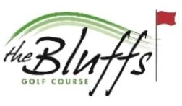
South Dakota Open Pro-Am
July 9-11, 2021
(605) 677-7058
Amateur Entry Form

NAME:_________________________________ ADDRESS:______________________________ EMAIL:_________________________________
Cell phone:________________________________
GHIN #:______________

Amateur entry MUST be paid at the time entry form is turned in. Entry Fee:

member $125
non-member $175

CART: $60 Yes___ No___
(includes practice round)

The Bluffs Pro Am to benefit Junior Golf….additional donation_______

Total Enclosed $:_____________
(Checks payable to: The Bluffs Pro-Am)

Refund Policy:
*Any cancellations made before June 28th will receive full refund less $50 administration fee. *Any cancellations made after June 28th will forfeit entry fee.

Return Entries To:
The Bluffs Golf Course
2021 E. Main St.
Vermillion, SD 57069

